Ejercicio

Se va a instalar una red de computadores con el diagramada adjuntado. La dirección IP a utilizar como referencia es 172.19.7.4 . Completar la tabla de direcciones IP e indicar en el diagrama la dirección ip adjudicada a cada equipo(que lo necesite). Es importante que el diseño esté ajustado al número de subredes, en un futuro se plantea añadir más ordenadores pero no crear más subredes.
Anotación: En cada subred se van a conectar 100 ordenadores
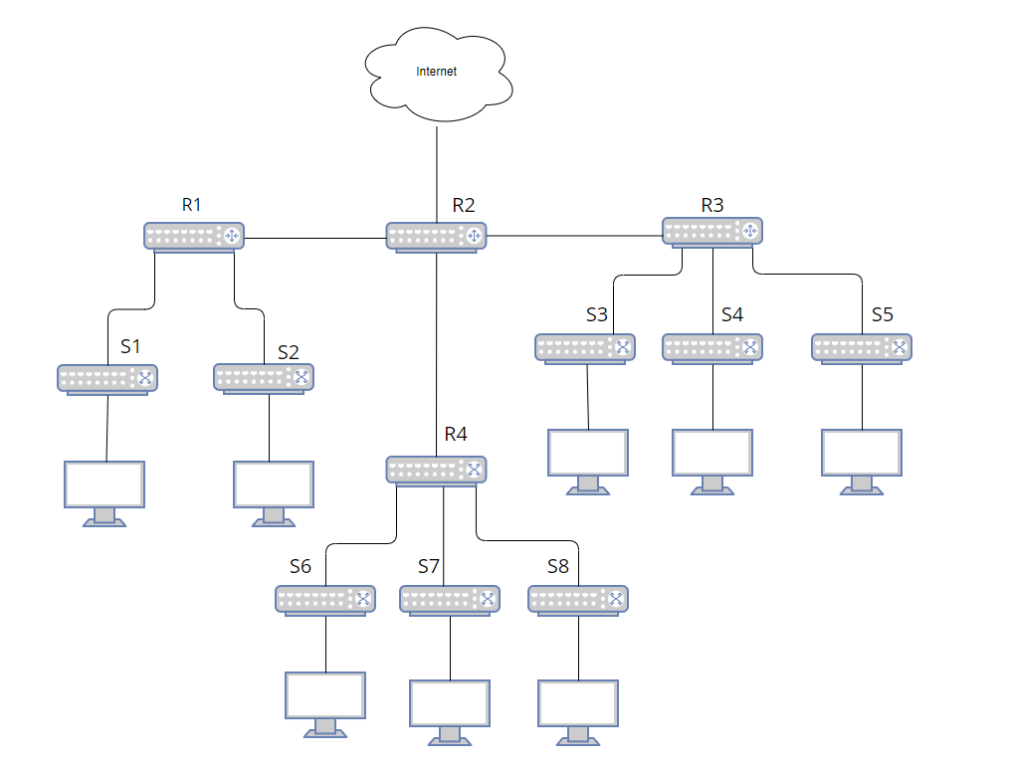
RED4
RED1
RED2
RED3
RED5
RED6
RED7
RED8
RED9
RED 10
RED 11
RED1 → FC00::0 → FC00::0:0:0:64 → ROUTER → FC00::65
RED2 → FC00:0:0:1::0 → FC00:0:0:1::64 → ROUTER → FC00:0:0:1::65
RED3 → FC00:0:0:2::0 → FC00:0:0:2::64 → ROUTER → FC00:0:0:2::65
RED4 → FC00:0:0:3::0 → FC00:0:0:3::64 → ROUTER → FC00:0:0:3::65
RED5 → FC00:0:0:4::0 → FC00:0:0:4::64 → ROUTER → FC00:0:0:4::65
RED6 → FC00:0:0:5::0 → FC00:0:0:5::64 → ROUTER → FC00:0:0:5::65
RED7 → FC00:0:0:6::0 → FC00:0:0:6::64 → ROUTER → FC00:0:0:6::65
RED8 → FC00:0:0:7::0 → FC00:0:0:7::64 → ROUTER → FC00:0:0:7::65
RED9 → FC00:0:0:8::0 → FC00:0:0:8::64 → ROUTER → FC00:0:0:8::65
RED10 → FC00:0:0:9::0 → FC00:0:0:9::64 → ROUTER → FC00:0:0:9::65
RED11 → FC00:0:0:A::0 → FC00:0:0:A::64 → ROUTER → FC00:0:0:A::65

Nombre  Subred | Máscara  Subred | Dir. Subred | Rango direcciones asignables | N.º Host posibles
1 | FC00::/64 | FC00:: | FC00::0  FC00::FFFF:FFFF:FFFF:FFFF | 16¹⁶
2 | FC00::/64 | FC00:0:0:1:: | FC00:0:0:1::0  FC00::1:FFFF:FFFF:FFFF:FFFF | 16¹⁶
3 | FC00::/64 | FC00:0:0:2:: | FC00:0:0:2::0  FC00::2:FFFF:FFFF:FFFF:FFFF | 16¹⁶
4 | FC00::/64 | FC00:0:0:3:: | FC00:0:0:3::0  FC00::3:FFFF:FFFF:FFFF:FFFF | 16¹⁶
5 | FC00::/64 | FC00:0:0:4:: | FC00:0:0:4::0  FC00::4:FFFF:FFFF:FFFF:FFFF | 16¹⁶
6 | FC00::/64 | FC00:0:0:5:: | FC00:0:0:5::0  FC00::5:FFFF:FFFF:FFFF:FFFF | 16¹⁶
7 | FC00::/64 | FC00:0:0:6:: | FC00:0:0:6::0  FC00::6:FFFF:FFFF:FFFF:FFFF | 16¹⁶
8 | FC00::/64 | FC00:0:0:7:: | FC00:0:0:7::0  FC00::7:FFFF:FFFF:FFFF:FFFF | 16¹⁶
9 | FC00::/64 | FC00:0:0:8:: | FC00:0:0:8::0  FC00::8:FFFF:FFFF:FFFF:FFFF | 16¹⁶
10 | FC00::/64 | FC00:0:0:9:: | FC00:0:0:9::0  FC00::9:FFFF:FFFF:FFFF:FFFF | 16¹⁶
11 | FC00::/64 | FC00:0:0:A:: | FC00:0:0:A::0  FC00::A:FFFF:FFFF:FFFF:FFFF | 16¹⁶

